ASSIGNMENT – 1
LLM POWERED CHATBOT Using SmolLM2-1.7B-Instruct
NAME : Akanksha Sandeep Netkar
COURSE : SYMCA
ROLL NO : 99
EMAIL: akankshamca2025_99@ncrdsims.edu.in
SUBJECT: GENERATIVE AI
COLLEGE: NCRD’s Sterling Institute of Management Studies

INDEX

SR. NO. | TITLE
1 | Language: Python
2 | Tool: Google Colab
3 | LLM Model: SmolLM2-1.7B-Instruct
4 | Framework: Hugging Face Transformers
5 | Deep Learning Library: PyTorch
6 | User Interface: Gradio
7 | GPU: NVIDIA Tesla T4
8 | Project: LLM Powered Chatbot

LLM-Powered Conversational Chatbot Using a Free Pre-Trained Model

AIM

To design and implement an LLM-powered conversational chatbot using a free pre-trained language model in Google Colab, with Python, Hugging Face Transformers, PyTorch, and Gradio.

ABSTRACT
Large Language Models (LLMs) have become an important part of modern Artificial Intelligence and Natural Language Processing applications. This project focuses on the development of an LLM-powered conversational chatbot using a free, pre-trained language model in the Google Colab environment.
The chatbot uses SmolLM2-1.7B-Instruct, a pre-trained instruction-tuned language model, to understand user prompts and generate natural-language responses. The project is implemented using Python, PyTorch, Hugging Face Transformers, Accelerate, and Gradio.
The Hugging Face Transformers library is used to load the model and tokenizer. The tokenizer converts user input into tokens that can be processed by the language model. The model then performs inference and generates a response using autoregressive text generation. Conversation history is maintained so that the chatbot can respond in the context of previous messages.
Gradio is used to create an interactive web-based interface through which users can enter questions and receive AI-generated responses.
The project demonstrates important concepts including Artificial Intelligence, Generative AI, Natural Language Processing, Large Language Models, Transformers, Tokenization, Prompt Processing, Model Inference, Text Generation, and Conversational AI.

INTRODUCTION
Artificial Intelligence has significantly changed the way humans interact with computer systems. Traditional software applications generally depend on predefined rules and instructions, whereas modern AI systems can understand natural language and generate meaningful responses.
A Large Language Model (LLM) is a type of deep-learning model trained on large amounts of textual data. LLMs are capable of understanding language patterns and generating human-readable text based on a given prompt.
Conversational AI uses these capabilities to develop systems that can communicate with users using natural language.
In this project, a conversational chatbot is developed using a pre-trained LLM rather than training a language model from scratch. The model is integrated with Python and exposed through a simple graphical interface using Gradio.

OBJECTIVES
The main objectives of this project are:
- To understand the basic concepts of Large Language Models.
- To understand the concept of Generative AI.
- To use a free pre-trained language model for text generation.
- To load and use a tokenizer for processing natural-language input.
- To understand the working of a Transformer-based language model.
- To perform inference using a pre-trained LLM.
- To maintain conversational history between the user and chatbot.
- To implement text generation using configurable generation parameters.
- To create an interactive chatbot interface using Gradio.
- To execute the complete application using Google Colab.

TECHNOLOGIES USED

Google Colab
Google Colab is a cloud-based development environment that allows Python programs to be executed through interactive notebooks. It is useful for machine-learning experimentation and can provide access to GPU resources.

Python
Python is used as the primary programming language for implementing the chatbot.

PyTorch
PyTorch is a deep-learning framework used for performing the numerical computations required to run the language model.

Hugging Face Transformers
Transformers provides tools for loading pre-trained language models and tokenizers and performing text generation.

SmolLM2-1.7B-Instruct
SmolLM2-1.7B-Instruct is the pre-trained instruction-tuned language model used in this project.

Gradio
Gradio is used to create the web-based graphical user interface for the chatbot.

Accelerate
Accelerate helps manage model execution across available hardware such as CPU and GPU.

SYSTEM ARCHITECTURE
The chatbot follows the architecture shown below:
USERGRADIO UIgenerate_response FunctionChat Template & Conversation DataTokenizerSmolLM2 Transformer LLMGenerated TokensDecodeAI ResponseGRADIO UI

IMPLEMENTATION

Import Required Libraries
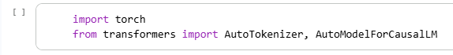

Check Hardware
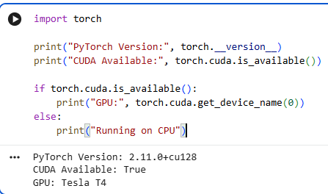
- Installation of required libraries
- Model selection
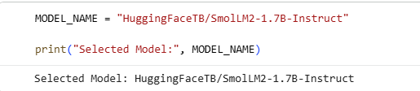

- Loading the tokenizer
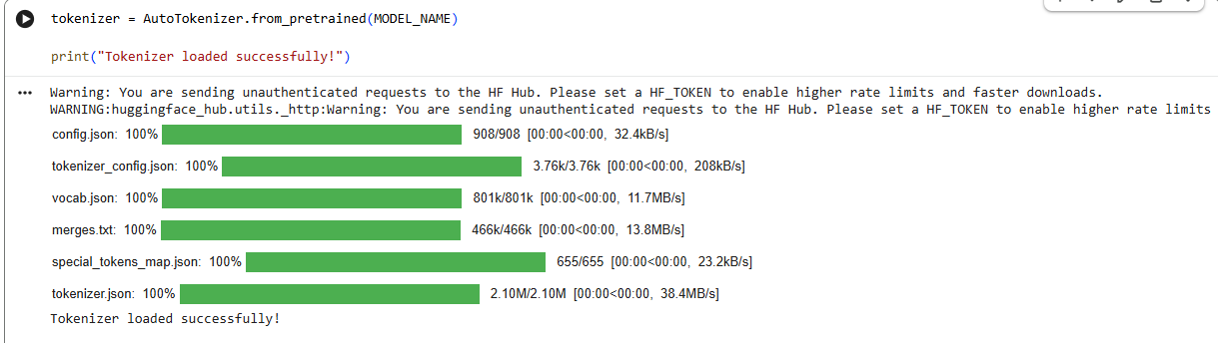
- Loading the LLM
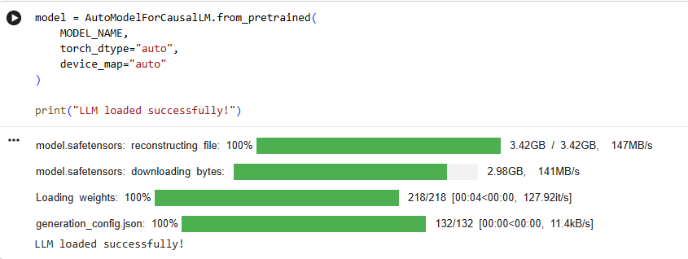
- Testing the chatbot
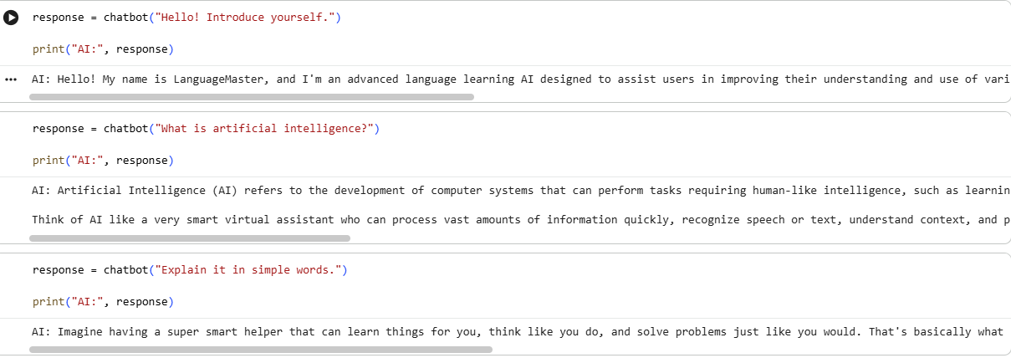
CREATE THE CHATBOT UI
- Check Gradio
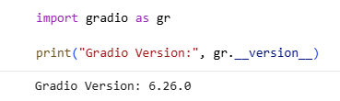

- Create the Gradio Interface
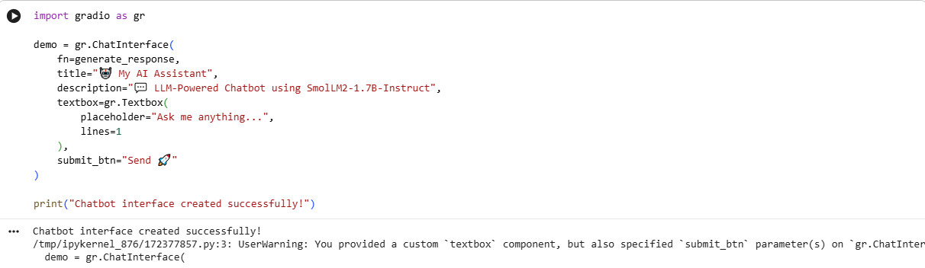
- Launch the Chatbot
